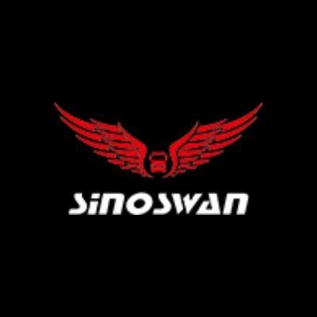
Elevated Stage Solutions for Professional Mobile Events
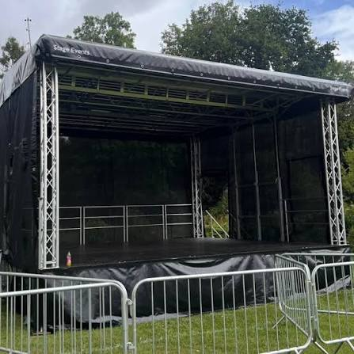
Modern events require flexible staging solutions that can create a strong visual impact while providing a clear and professional presentation area. An elevated stage offers an effective way to improve audience visibility and organize different types of outdoor activities. It can be used for concerts. Festivals. Corporate programs. Product launches. Public gatherings. Community events and promotional campaigns. A raised platform can also provide suitable space for audio equipment. Lighting systems. LED displays and other event technology.
Sinoswan develops mobile stage and event solutions for organizations that need flexible platforms for different locations. Mobile staging can reduce the need for permanent construction while providing a professional environment for presentations and performances. These solutions are designed to support events that require transportation. Quick setup and practical functionality.

What Is an Elevated Stage?
An elevated stage is a raised platform designed for performances. Presentations. Speeches and public activities. Its raised structure helps speakers and performers remain visible to audiences. This is especially useful for large outdoor gatherings where people may be standing at different distances from the presentation area.
Unlike a basic ground-level platform. An elevated design can create a stronger visual focus for an event. It can also provide room for different types of event equipment. Depending on the configuration. The stage can accommodate sound systems. Lighting equipment. LED screens and presentation technology.
Mobile versions can be transported to different locations. This makes them suitable for organizations that regularly organize outdoor events. Roadshows and temporary programs. A professional mobile stage can turn an open area into a functional event venue without requiring permanent construction.

Benefits of an Elevated Stage
One of the main advantages of an elevated stage is improved visibility. Raising the presentation area allows audiences to see speakers and performers more easily. This can be particularly important during concerts. Public meetings. Festivals and large community programs.
Flexibility is another major benefit. Mobile staging can be used at different venues according to the event schedule. Organizers can transport the unit to a selected location and prepare the platform for the planned activity. This approach can be more practical than constructing a temporary stage from scratch for every event.
An elevated stage can also support professional event technology. Lighting fixtures can be positioned to illuminate performers. Audio equipment can be arranged for better sound distribution. Large LED displays can be integrated to show presentations. Branding and promotional content.
A stable and professionally designed structure is also important. Event organizers need a platform that is appropriate for the intended activity and operating environment. Proper planning and professional installation can help create a safer and more organized event setup.

Elevated Stage for Outdoor Events
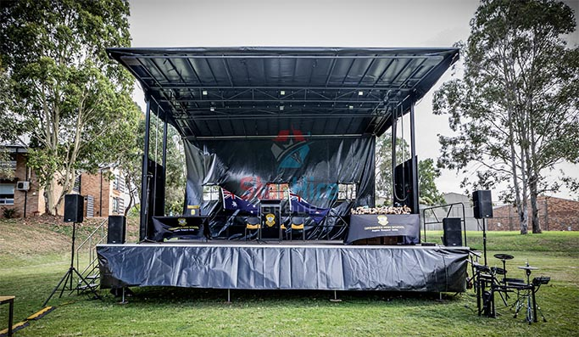
Outdoor events often require staging systems that are flexible and easy to adapt to different locations. An elevated stage can provide an organized platform for concerts. Festivals. Corporate events. Community programs and public activities.
Outdoor venues may not have permanent staging infrastructure. A mobile solution can therefore provide a convenient alternative. The platform can be transported to an event location and prepared according to the specific requirements of the program.
Mobile stages can also be useful for roadshows and promotional activities. Businesses can travel to different areas while maintaining a consistent presentation setup. This can help create a recognizable event environment while reducing the need to arrange separate staging equipment at every location.
Sinoswan focuses on mobile event technology that combines transportation with practical stage functionality. Its solutions can be adapted for different event formats and operational requirements.

Supporting Emergency Operations With an Emergency Medical Trailer
Mobile infrastructure is not limited to entertainment and promotional events. An emergency medical trailer can provide a flexible option for organizations that need temporary medical facilities at different locations.
An emergency medical trailer can be configured to support medical personnel during public gatherings. Emergency response activities. Community programs and temporary healthcare operations. Depending on the application. A mobile medical unit may include dedicated areas for assessment. Treatment. Equipment storage and other essential functions.
Large public events may require both presentation facilities and emergency support. An elevated stage can serve as the central presentation area while a mobile medical unit can provide a dedicated location for medical assistance.
This combination can help event organizers plan a more complete mobile infrastructure. Specialized vehicles and trailers can be transported to locations where temporary facilities are required. The exact configuration should always be selected according to operational requirements and applicable safety regulations.

Election Campaign Truck for Mobile Public Engagement
Public campaigns often require communication solutions that can reach people in different communities. An election campaign truck can provide a mobile platform for speeches. Public communication. Campaign events and community engagement.
An election campaign truck can be equipped with LED displays. Audio systems. Presentation equipment and other communication technology. These features can help campaign teams communicate messages while traveling between different locations.
A raised presentation platform can make speakers more visible to the surrounding audience. When an election campaign truck incorporates an elevated platform. The vehicle can function as a mobile event venue for speeches and campaign activities.
Mobile campaign vehicles can also be useful for awareness programs and community outreach. Organizations can visit multiple locations without constructing a separate temporary presentation area at every stop.

Why Choose Sinoswan for Mobile Stage Solutions?
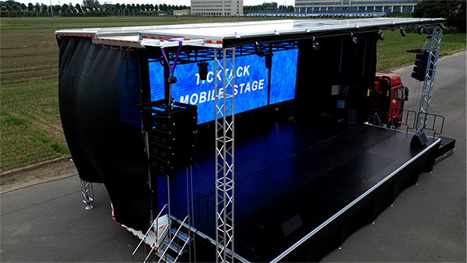
Sinoswan provides mobile stage solutions designed for organizations that need flexibility. Mobility and professional event functionality. Its approach focuses on developing practical platforms that can support different types of outdoor programs.
An elevated stage solution can be developed according to the requirements of the event. Different projects may require different platform sizes. Display systems. Lighting arrangements. Audio equipment and working areas. A customized approach allows organizers to select features that match their intended application.
Mobile staging can also help organizations manage repeated events. Instead of arranging a completely new structure for every location. A suitable mobile platform can be transported between venues and configured for different programs.
Professional mobile event solutions can support concerts. Corporate events. Product launches. Roadshows. Public campaigns and community activities. The right configuration can help create a more organized and engaging environment for both presenters and audiences.

Applications of an Elevated Stage
An elevated stage has applications across many event categories. It can be used for outdoor concerts. Corporate presentations. Product demonstrations. Festivals. Community gatherings. Government programs. Brand activations and public awareness campaigns.
It can also be valuable for roadshows where organizations need to take their presentations directly to different locations. A mobile stage can provide a recognizable platform while allowing the event team to maintain consistent equipment and branding.

For public communication activities. An election campaign truck can combine transportation with presentation capabilities. For emergency response operations. An emergency medical trailer can provide a dedicated mobile facility where temporary medical support is required.
These different applications show the versatility of mobile infrastructure. By selecting the right platform and equipment. Organizations can create event solutions that are suitable for changing locations and operational requirements.

Create Professional Mobile Events
Choosing the right staging system can have a significant effect on audience experience. A professionally planned elevated stage can improve visibility and provide an organized area for speakers. Performers and event equipment.
Mobile solutions can be particularly valuable when an event needs to travel between different locations. They can provide greater flexibility than fixed structures while supporting modern event technology.
Sinoswan offers mobile solutions for organizations looking to develop practical and professional event setups. With suitable planning. A mobile stage can support different applications ranging from entertainment and corporate programs to public campaigns and community activities.
An elevated stage is more than a raised platform. It can become the central part of a complete mobile event solution when combined with LED displays. Professional audio. Lighting systems and other event technology. For organizations planning outdoor programs. Roadshows or public engagement activities. choosing a suitable mobile stage can help create a professional and memorable experience.
Contact Details:
Website: Sinoswan
Email: info@sinoswan.com
Tel: +8618538129701
WhatsApp Business: +8618838950310
WhatsApp: +8618637178390
WeChat: +86 18538129701
YouTube: Sinoswan on YouTube
Visit : Alibaba

